Module:

Customer Discovery

OVERVIEW

Learning Objectives

At the conclusion of this module, you will be able to:
- Interpretation: Describe the purpose and importance of the customer discovery process.
- Evaluation: Outline the basic steps in the customer discovery process.
- Evaluation: Identify who could provide input on a new idea.
- Application: Formulate questions to ask during the customer discovery process.

Checklist

Prior to meeting with mentor:
- Review the information provided in this module and complete all deliverables.
- Complete the Five-Minute Reflection.
- Write a list of questions you may have after completing the module to discuss with your mentor.

Materials for this Module
- YouTube Video: “What is Customer Discovery?” by Steve Blank https://www.youtube.com/watch?v=vw1_-WyOtxk (2.5 minutes)
- YouTube Video: “REM Customer Discovery – Listening with a Purpose” by Karen Burg and Tim Burg https://youtu.be/gi7x7hji-AA (26 minutes)
- Handout 1: Business Model Canvas

Introduction
As we pursue our careers and interests, we seek to create new ideas or products that someone wants:
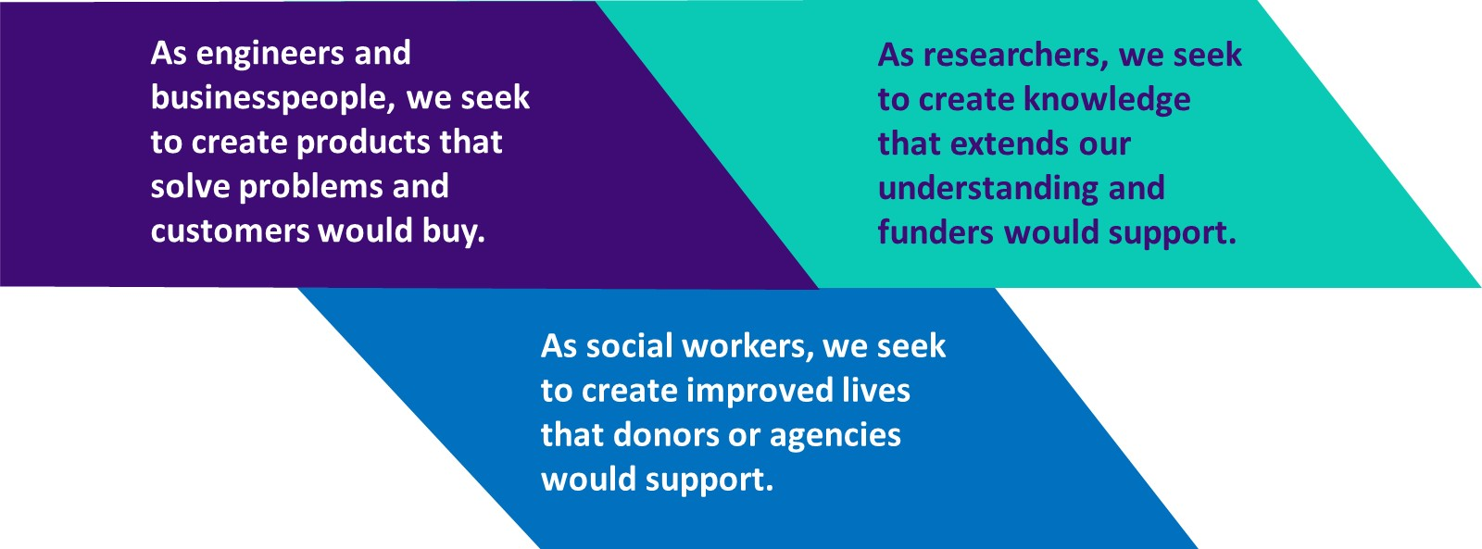

All of these endeavors are like solving complex puzzles. Where then do we find the pieces we need to complete the puzzle? We all know that we should review the literature to find what has been done and suggestions for next steps. There is a lot of information available at our fingertips and it is easy to become complacent and believe this is ALL of the information we need. The Customer Discovery process says that the people around a particular problem have valuable insights, information, anecdotes, history, … that will help us understand the “customer” and their needs. These people may not look like experts, or be labeled as experts, but this is where we must ask good questions and listen carefully.
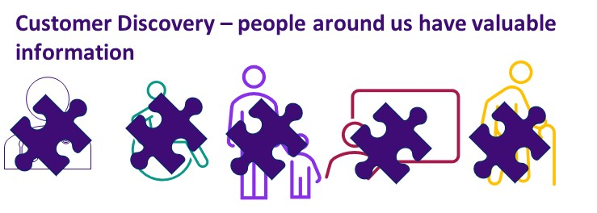
Oftentimes as researchers we can find ourselves solving problems that may not exist. It is very easy to get excited about a scientific discovery or a new engineering design only to find out much later on that there is no real value in our product. The customer discovery process is a method by which you discover market needs based on interviews with industry professionals without letting your own biases lead you astray. The process can be simplified into the following steps:

- Observing a problem that potentially needs to be solved. Addressing assumptions relating to your hypothesis.
- Identifying professionals within a target market and related fields that can provide first-hand knowledge regarding deficiencies in the market.
- Re-evaluate hypothesis and assumptions and refine. Repeat steps as necessary.

Once a potential problem has been identified, you must verify that two basic assumptions are met. The first is that what you believe to be a problem is in fact a deficiency that needs to be addressed, and the second is that someone is willing to pay for a solution to that problem. Speaking with stakeholders (experts/users/influencers/professionals/…) within your target market is the most efficient way to confirm that both those assumptions are true, and if necessary, course correct your current trajectory in the engineering process.

Gathering critical information from the right people may be a daunting task but can be easily managed if carefully thought out beforehand. The first step is identifying the potential end user(s) of your product. This could be an end user from a single profession, or it could target a more generalized audience (Ex. A nurse using a stethoscope vs general public using a hammer). Once you have identified potential end users, you can then broaden your list to other professionals that will need to be consulted to bring your product to market. From a product development prospective this could mean speaking to other engineers or researchers, consulting with manufacturers on scaling up your design, as well as speaking with business managers, marketing, and advertising specialists.

Once you’ve identified potential customers/professionals, you need to carefully think about a series of questions to ask during your interview. These questions should be as open-ended as possible. This isn’t to get feedback on your ideas or validate your own biases, the purpose is to let the customer lead you to the solution. Your questions should be nonspecific to your design and should focus on gaining a broad understanding of the challenges your client currently faces. Some example questions that can be applied to many fields…

• What does a typical day look like for you in the workplace?
• What do you like/dislike most about your job?
• What are the most difficult challenges you face?

If you structure your interview in an open-ended way, you will often find yourself asking many follow up questions and discovering things that never occurred to you in the first place. Let the customer lead you naturally, don’t lead the customer. At the end of each interview always ask if there is anything else you should be asking. More often than not, there are so many things we wouldn’t even know to ask. This question can elucidate something that may be important to your client but would have never occurred to us as the engineer. Also, be sure to ask if your interviewee could connect you with additional professional contacts that can assist during your customer discovery process.

Finally, once you’ve finished with the interview you will need to take the information you have learned and assess your next steps. You may find the interview led you to a totally new direction that you want to explore, or maybe you are even more confident your idea solves a very real problem. In either case, you will need to apply the new information to your idea as well as continue to interview potential customers/professionals in your target market.

Assignment(s) for this Module
Understanding Customer Discovery:
Watch this short YouTube video “What is Customer Discovery?” by Steve Blank, summarizing an organized method to understanding the views of people (“customers”) affiliated with your idea or invention: https://www.youtube.com/watch?v=vw1_-WyOtxk Review Handout1 that describes the elements of Customer Discovery and shows the Business Model Canvas

With the video and Handout 1 as background, determine whether or not each question is leading or open-ended and state your reasoning. For leading questions, rewrite the question to be open-ended.
1. You always go into the office on the weekends, right?
2. What is your favorite part of the day?
3. Isn’t it true that the tests were always positive?
4. Is a screwdriver or a drill the best tool for this job?
5. What is the weather like for this area?
6. Does it take 30 minutes to complete this task?
7. How many times do you vacation each year?

Deliverable 1: Document your responses for each question.

Defining the Customers:
You are working in an engineering lab that discovered a novel way to screen blood samples for a diagnostic test. You believe this could have a large impact on medical diagnostic testing but you need to learn more about the current market and potential customer needs. Create a list of potential people you should connect with to learn more about the market (think from all perspectives…clinical, engineering, financial, etc.).

Deliverable 2: Document your list of customer groups.

Preparing for Customer Interviews:
Now that you have a list of people in mind, choose one of those people and come up with a list of at least 5 potential questions for that interview. Remember to phrase questions in an open-ended or non-leading manner.

Deliverable 3: Document your list of 5 open-ended questions.

Five-Minute Reflection:
- Why is the customer discovery process important?
- Formulate one question to discuss with your mentor (maybe a concept you are unclear on, something you found interesting, etc.)
- What information did you feel was the most informative? Least?

Deliverable 4: Document your responses to the Five-Minute Reflection.

Mentee Deliverables:
- Deliverable 1: Save a copy of your designation of the questions as open-ended or leading and corrections to the leading questions.
- Deliverable 2: Save a copy of your list of customer groups.
- Deliverable 3: Save a copy of your list of open-ended questions.
- Deliverable 4: Save a copy of your responses to the Five-Minute Reflection.
- Deliverable 5: Send an electronic file containing the deliverables to your mentor, preferably the day before your next meeting and bring a printed or electronic copy to discuss at your next Mentor meeting.

Discussion with mentor:
- Review the Handout 1 regarding customer discovery
- How might you refine/add to your customer list?
- Discuss topics from Five-Minute Reflection.

Summary
- There is a lot of information available at our fingertips and it is easy to become complacent and believe this is ALL of the information we need.
- The Customer Discovery process says that the people around a particular problem have valuable insights, information, anecdotes, history, … that will help us understand the “customer” and their needs.
- Customer Discovery works for many endeavors, including reasearch

Checklist

Prior to meeting with mentor:
- Watch the two videos
- Review Handout 1: Customer Discovery
- Review the sample questions as open-ended or leading and correct as needed.
- For the sample interview scenario, create a list of customer groups and a list of open-ended questions you could ask.
- Complete Five-Minute Reflection

